Understanding that some users must print sensitive documents, they have the option to do a delayed secure print so that no confidential documents are generated until they are at the printer. Here’s how:

- When ready to print the document, click on the Office Button at the top left of your document 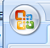and select Print.
- Select the printer to which you want to print- a secure print feature is available on both of the printers in the Shiloh office.
- For either printer, click Properties next to the printer you’ve selected
- For the Ricoh printer, in the Setup tab, click the drop down arrow under Job Type and select Locked Print, then click the Details button:
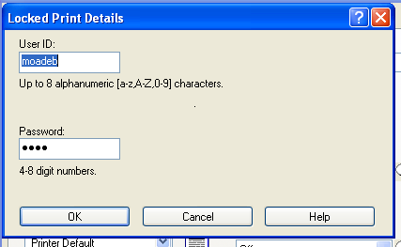
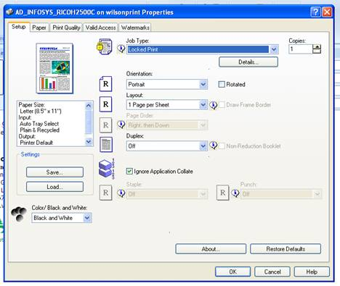
- In the details dialog box, enter your username in the User ID box and choose whatever pin code you wish to use, then OK

- For the HP 3505 laser printer, select the Job Storage tab, then select Personal job under the Job Storage mode. You will then be able to select PIN to print and add a PIN in there to retrieve it.
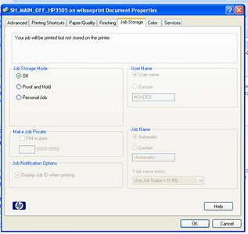
- Once you are ready, go to the printer. For the Ricoh, on the display select Print Jobs, then Locked print jobs. Select your job from the list, click print on the display and enter the PIN you used.
- For the HP laser print, click Menu- it will be a similar selection to print.

